ASSIGNMENT 3: LOGISIM

U19CS012

Use Logisim software to create and store the followings circuits for further usage: (For Practice)

1. 1-bit Half Adder

Build a 1-bit half adder. This takes two input wires, x0 and x1, and generates two output wires, s for the sum and c for the carry.

Circuit Image:

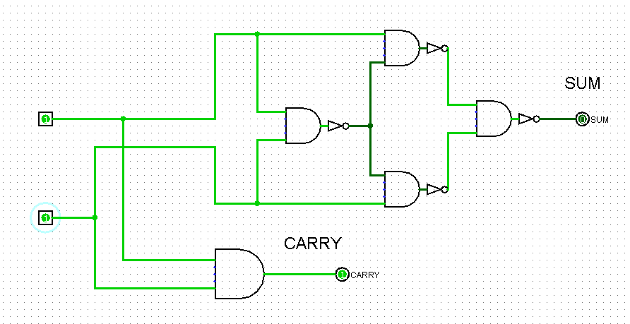

Truth Table:

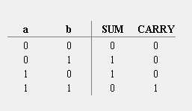

2. 1-bit Full Adder

The half-adder from the previous exercise can't be composed to make larger adders because it doesn't take a carry input, which is necessary if we're to chain then. Build a 1-bit full adder which takes c_in, x0, and x1 as inputs, and generates s and c. (Note that we don't need any additional outputs here.)

Circuit Image:

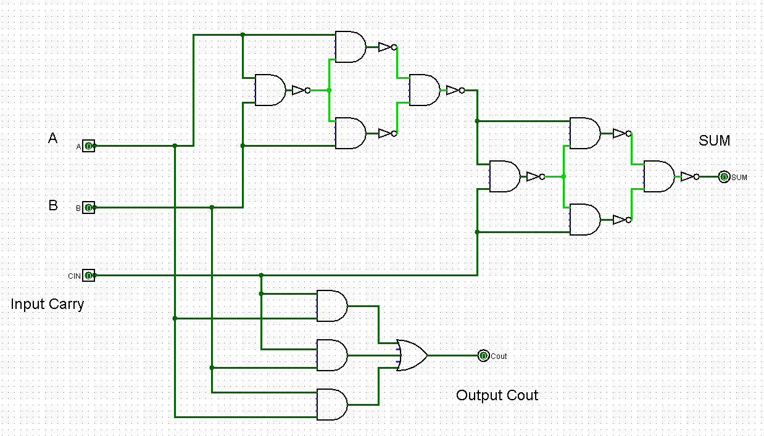

Truth Table:

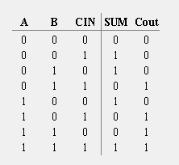

3. 1-bit Half Subtractor

Build a 1-bit half subtractor. This takes two input wires, x0 and x1, and generates two output wires, D for the difference and c for the borrow.

Circuit Image:

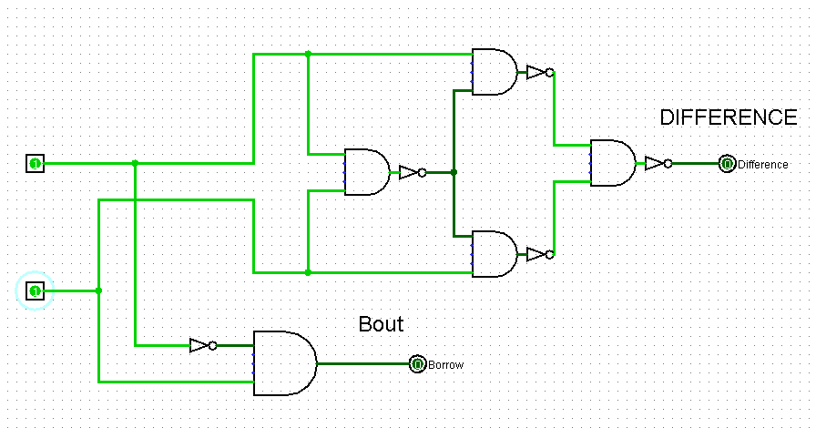

Truth Table:

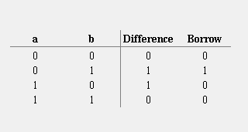

4. 1-bit Full Subtractor

Build a 1-bit full subtractor which takes c_in(Borrow), x0, and x1 as inputs, and generates D(Difference) and c(Borrow).

Circuit Image:

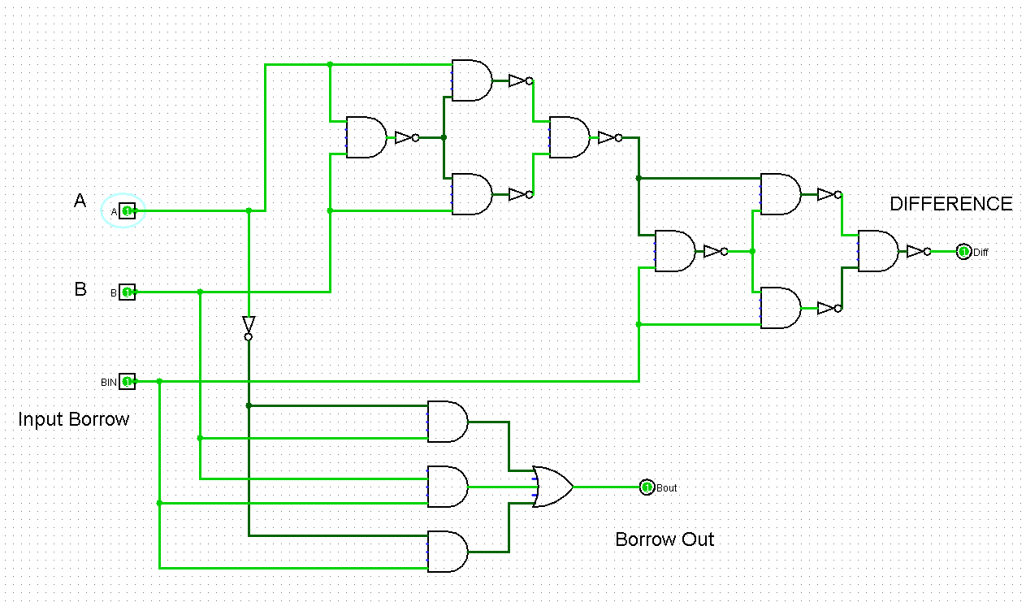

Truth Table:

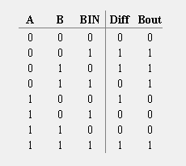

Submitted By:

Roll Number: U19CS012 (D-12)

Name: Bhagya Rana